Name:
Date:
School:
Facilitator:

9.05 Coloring the EM Spectrum
Complete all 6 parts of this activity about the electromagnetic spectrum. You will need colored pencils and a calculator to complete this assignment. Please print this document and either scan it in or take a picture of it in order to submit your completed work.

Part 1: Introduction
Light is but one kind of wave found in the electromagnetic spectrum. The electromagnetic spectrum consists of all the different forms of radiation that result from vibrating electric and magnetic fields (which are at right angles to one another). Although each form of radiation is caused by these vibrations, varied forms of radiation occur due to different frequencies, wavelengths, and energies.
In this activity, you will determine characteristics of electromagnetic waves and visible light waves.

Part 2: Electromagnetic Radiation
Table 1 below lists the names of the different forms of electromagnetic radiation and their associated frequencies. The wavelength and energy of radio waves have been calculated for you. Determine the wavelengths and energies of the remaining forms, as follows:
- For any wave—be it an ocean wave, a sound waves, or an electromagnetic wave—the following relationship holds true:
  - Wavelength x frequency = velocity

  - Electromagnetic waves all travel at the speed of light. Thus:
Wavelength (m) x frequency (Hz) = 3.00 x 10⁸ m/s

  - To calculate wavelength, divide the speed of light by frequency. Record your answers in Column 3 of the table below. The unit for the resulting wavelength will be the meter (m).

- Because the wavelengths of electromagnetic waves are so small, they are often expressed in nanometers, rather than meters. To complete Column 4, multiply the wavelengths in Column 3 by 1 x 10⁹.

- The energy of electromagnetic waves can be calculated by multiplying their frequencies by a constant, h (known as Planck's constant).
  - That is: energy = h x frequency

  - To calculate energy, multiply the frequency by 6.626 x 10⁻³⁴ J·s. Record your answers in Column 5. The unit for the resulting energy will be the joule.

Table 1: Characteristics of Electromagnetic Radiation

Type of Wave | Frequency (Hz) | Wavelength (m) | Wavelength (nm) | Energy (J)
Radio | < 3 x 10⁹ | > 0.1 | > 1x 10⁸ | < 2.0 x 10 ⁻²⁴
Microwave | 3 x 10⁹ to  3 x 10¹²
Infrared | 3 x 10¹² to  4.3 x 10¹⁴
Visible | 4.3 x 10¹⁴ to  7.5 x 10¹⁴
Ultraviolet | 7.5 x 10¹⁴ to  3 x 10¹⁷
X-rays | 3 x 10¹⁷ to  3 x 10¹⁹
Gamma | > 3 x 10¹⁹

Part 3: Visible Light
Notice that visible light makes up a very small portion of the electromagnetic spectrum. Table 2 (below) lists all of the colors of visible light and their associated frequencies. Repeat steps 1-3 from Part 2 (these steps are also listed below) to complete Table 2. The first row has been completed for you.

- Calculate wavelength by dividing the speed of light by frequency.
  - Electromagnetic waves all travel at the speed of light: 3.00 x 10⁸ m/s
  - The unit for the resulting wavelength will be the meter (m).
  - Record your answers in Column 3 of the table below.

- Because the wavelengths of electromagnetic waves are so small, they are often expressed in nanometers, rather than meters. To complete Column 4, multiply the wavelengths in Column 3 by 1 x 10⁹.

- The energy of electromagnetic waves can be calculated by multiplying their frequencies by a constant, h (known as Planck's constant).
  - That is: energy = h x frequency
  - To calculate energy, multiply the frequency by 6.626 x 10⁻³⁴ J·s. Record your answers in Column 5. The unit for the resulting energy will be the joule.

Table 2: Characteristics of Visible Light
Color | Frequency (Hz) | Wavelength (m) | Wavelength (nm) | Energy  (J)
Red | 4.3 x 10¹⁴ to 4.8 x 10¹⁴ | 6.98 x 10⁻⁷ to  6.25 x 10⁻⁷ | 698 to 625 | 2.8 x 10⁻¹⁹ to  3.2 x 10⁻¹⁹
Orange | 4.8 x 10¹⁴ to 5.2 x 10¹⁴ | to | to | to
Yellow | 5.2 x 10¹⁴ to 5.6 x 10¹⁴ | to | to | to
Green | 5.6 x 10¹⁴ to 6.2 x 10¹⁴ | to | to | to
Blue | 6.2 x 10¹⁴ to 7.0 x 10¹⁴ | to | to | to
Violet | 7.0 x 10¹⁴ to 7.5 x 10¹⁴ | to | to | to

Part 4: Electromagnetic Spectrum
Now that you have completed Tables 1 and 2, you can create a labeled diagram of the electromagnetic spectrum. The electromagnetic spectrum (diagram below) indicates the frequencies associated with different types of waves. You will need colored pencils and you will need to print the document.
Complete the diagram as follows:
- Label each block under the Frequency heading with the wave type (radio, visible, etc.). You should list all 7 types of waves.

- In the rectangle representing all the frequencies of visible light (on the right side of the diagram), color each block the appropriate color.

- Label each line in the blocks under the Wavelength and Energy headings with the values you calculated in Tables 1 and 2. You should list 6 wavelengths (nm) and 6 items under energy (J).

- In the blocks under the Velocity headings, indicate the velocity of electromagnetic waves. Write this information vertically, since all electromagnetic waves have the same velocity.

- Next to each of the Frequency columns, draw a red arrow that indicates the direction in which frequency increases. You should draw 2 red arrows.

- Next to each of the Wavelength columns, draw a blue arrow that indicates the direction in which wavelength increases. You should draw 2 blue arrows.

- Next to each of the Energy columns, draw a green arrow that indicates the direction in which energy increases. You should draw 2 green arrows.

Electromagnetic Spectrum Diagram

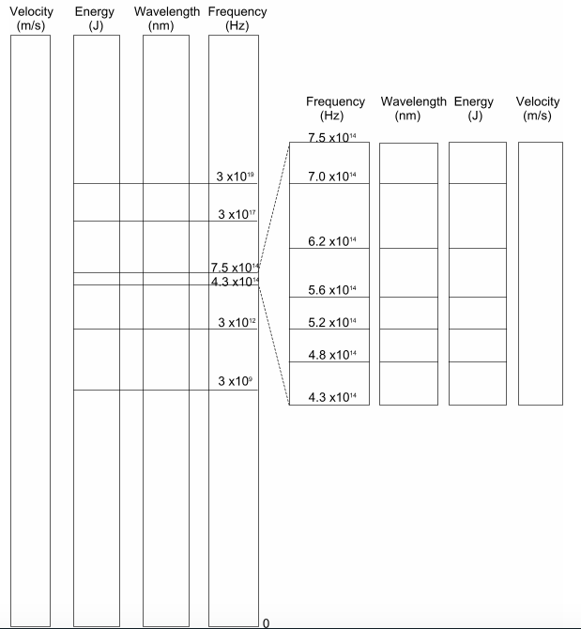

Part 5: Analysis and Calculations
Use the completed tables and diagram to answer the following questions.
- Identify the type of wave in the electromagnetic spectrum that has the:
  - highest frequency:
  - highest wavelength:
  - highest energy:
  - highest velocity:
  - lowest frequency:
  - lowest wavelength:
  - lowest energy:

- Identify and explain the types of electromagnetic waves. Give examples of devices and technologies that use each type.
  - Radio waves
    - Definition:

    - Examples that utilize this wave type:

  - Microwaves
    - Definition:

    - Examples that utilize this wave type:

  - Infrared waves
    - Definition:

    - Examples that utilize this wave type:

  - Visible light
    - Definition:

    - Examples that utilize this wave type:

  - Ultraviolet waves
    - Definition:

    - Examples that utilize this wave type:

  - X-rays
    - Definition:

    - Examples that utilize this wave type:

  - Gamma rays
    - Definition:

    - Examples that utilize this wave type:

- What color has the longest wavelength?

- What color has the shortest wavelength?

- High frequency waves have (long, short) wavelengths and are (high, low) in energy. (Select the correct answers from the options provided.)

- Electromagnetic waves with long wavelengths have (high, low) frequencies and are (high, low) in energy. (Select the correct answers from the options provided.)

- High energy waves have (high, low) frequencies and (long, short) wavelengths. (Select the correct answers from the options provided.)

- Sunlight contains both infrared and ultraviolet waves. Examine the electromagnetic spectrum you created. Which type of waves would be more damaging (i.e., more likely to promote cancer) and why?

Through this activity, you learned about the relationships among wavelength, frequency, and energy:
  - wavelength x frequency = speed of light (3.00 x 10⁸ m/s)
  - energy = h x frequency (h = 6.626 x 10⁻³⁴ J·s)
Use these two relationships to solve the following 3 problems. Show your work and indicate the appropriate units for your answers.
- What is the wavelength of a radar signal that operates at a frequency of 1.095 x 10¹⁰ Hz?

- Calculate the frequency of a microwave that has a wavelength of 0.0150 m.

- High-energy gamma rays are emitted by the sun. How much energy do such gamma rays possess, if they have a frequency of 1.0 x 10²⁵ Hz?

