Name:

Date:

School:

Facilitator:

7.03 Nephron Anatomy and Function

# Part A: Label the Nephron

# ****1. Identify the parts of the nephron on the diagram: (2 points each)****

**A =**

**B =**

**C =**

**D =**

**E =**

**F =**

**G = (Liquid)**

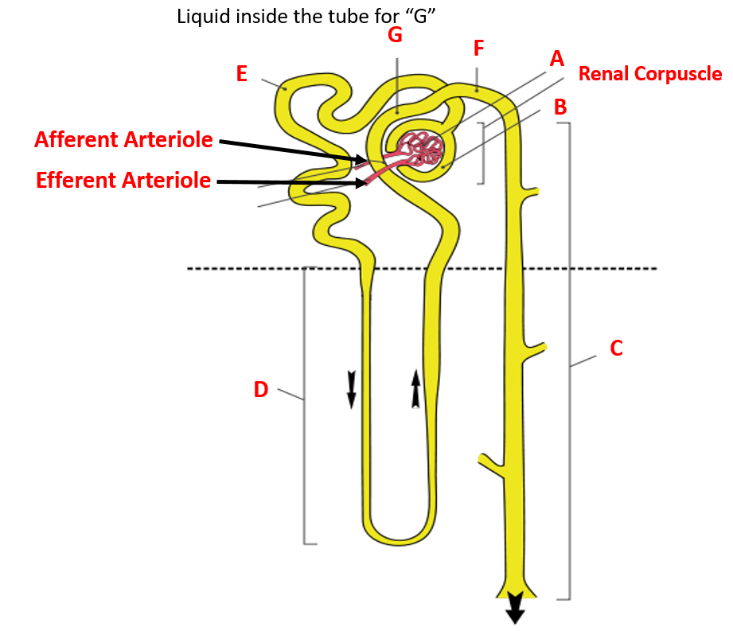

# Part B: Functions of the Nephron Parts

**Identify the parts of the nephron that perform the specific functions. (2 points each)**

1. Filtering the blood to produce the filtrate in the glomerular capsule is the function of the .

2. Reabsorption of water and salts can occur in the (choose only one location) .

3. Secretion of drugs and toxins from the blood occurs in the .

4. Reabsorption of water in the collecting duct is under the control of which hormone?

5. How much blood is filtered through healthy kidneys each minute (This is also termed the Glomerular Filtration Rate or GFR)?