Name:

Date:

School:

Facilitator:

1.05 Sound Waves

**Complete both parts of this task. Part 2 is listed on the next page.**

# Part 1: Parts of a Sound Wave

1. is the high point on a sound wave.
2. is the distance from the rest point to the crest on a sound wave.
3. is the low point on a sound wave.
4. is the distance between two adjacent crests on a sound wave.
5. is the straight, black line in the middle of the sound wave diagram, which is the medium that sound is travelling through.
6. In order for sound to be heard it must travel through a      .
7. True or False: There is no sound in outer space because sound cannot travel in the vacuum of outer space.
8. True or False: The larger the amplitude, the louder the sound and the smaller the amplitude, the softer the sound.
9. The wavelength determines the       of a note, which is how high or low a note is.
10. is defined as movement back and forth or up and down.

# Part 2: Label a Wave

**Using the provided word bank, label the parts of the sound wave. Note: Not all words will be used.**

**Word Bank:**

**Vibrations**

**Medium**

**Crest**

**Amplitude**

**Trough**

**Wavelength**

**Rest Position**

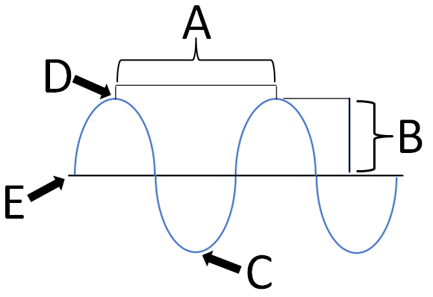

**A.**

**B.**

**C.**

**D.**

**E.**