Name:

Date:

School:

Facilitator:

1.02 Observing Line

**There are three parts to this journal assignment. Please complete all three parts using the information you learned in this lesson and the previous lesson. Use complete sentences, and remember to use the terminology you learned in the lesson as evidence in explaining your answers. Links to all 3 works of art discussed in this Task are included on the Task page.**

# Part 1: Wassily Kandinsky

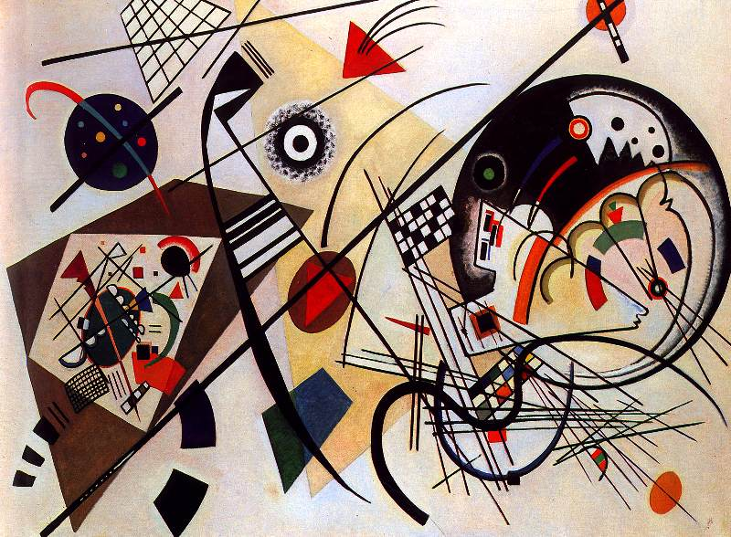  
*Throughgoing Line* or *Transverse Line* by Wassily Kandinsky, 1923

1. Describe three different lines that you see in this painting by Wassily Kandinsky.

1. How are these lines different from one another?

1. In what direction does your eye travel when you look at these lines? Describe your response for each of the three lines that you listed in the first question.

1. How do the lines in this painting make you feel? Refer to the line characteristics that you learned in the lesson.

# Part 2: Vincent van Gogh

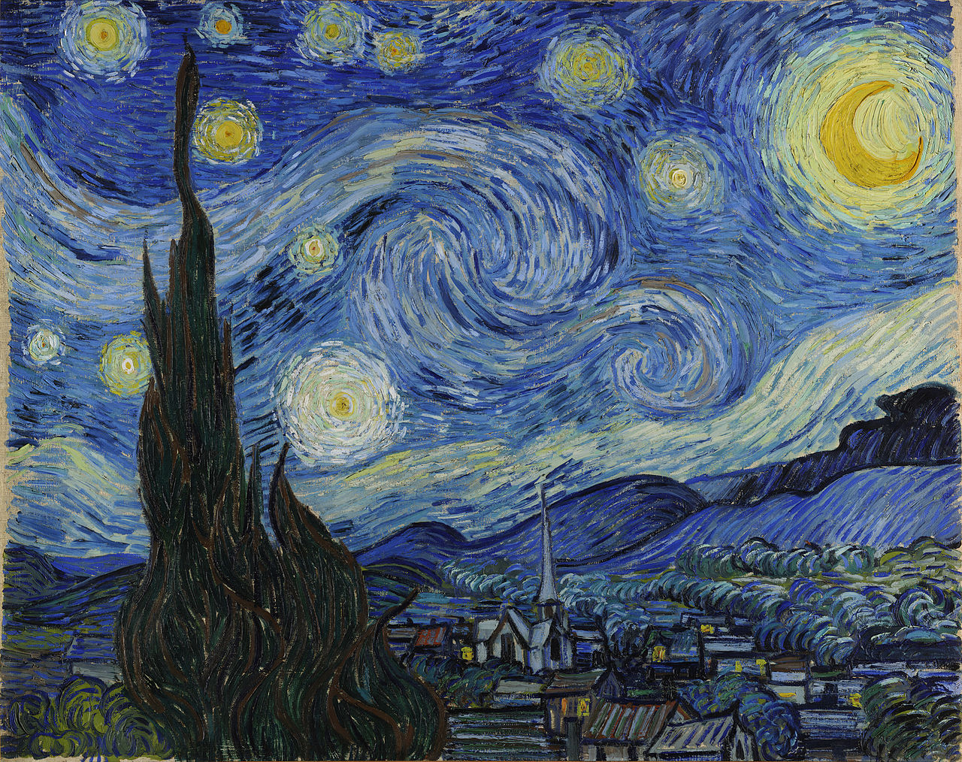

*The Starry Night* by Vincent van Gogh, 1889

1. What kind of lines does the artist use in this painting?

1. How do the lines in this painting by Vincent van Gogh move your eye from one side of the painting to the other?

1. How do the lines in this painting make you feel?

1. Why do you think the artist used these kinds of lines in this painting?

# Part 3: Bridget Riley

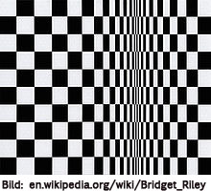

*Movement in Squares* © Bridget Riley , 1961

1. What kinds of lines does Bridget Riley use in this painting?

1. How does the artist change the lines in the painting and what effect does it have?

1. How are the lines in this painting different than the lines in the paintings in Part 1 and Part 2?

1. How do the lines in this painting make you feel?