Name:

Date:

School:

Facilitator:

1.04 Color Wheel

**Label all the colors on the color wheel by answering the questions. Use the word bank (on the second page) as needed.**

1. 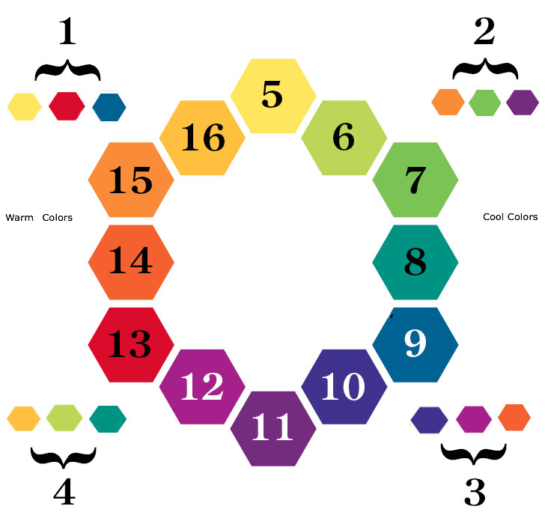Are the group 1 colors primary, secondary, or intermediate?
2. Are the group 2 colors primary, secondary, or intermediate?
3. Are the group 3 colors primary, secondary, or intermediate?
4. Are the group 4 colors primary, secondary, or intermediate?
5. Color:       Is it warm or cool?
6. Color:       Is it warm or cool?
7. Color:       Is it warm or cool?
8. Color:       Is it warm or cool?
9. Color:       Is it warm or cool?
10. Color:       Is it warm or cool?
11. Color:       Is it warm or cool?
12. Color:       Is it warm or cool?
13. Color:       Is it warm or cool?
14. Color:       Is it warm or cool?
15. Color:       Is it warm or cool?
16. Color:       Is it warm or cool?

**Word Bank:**

Blue

Blue-Green

Blue-Violet

Green

Intermediate Colors

Orange

Primary Colors

Red

Red-Orange

Red-Violet

Secondary Colors

Violet

Yellow

Yellow-Green

Yellow-Orange