Name:

Date:

School:

Facilitator:

1.01 Rational Numbers and Absolute Value

Total points: 40

# Part 1: Identify and Classify Subsets of Real Numbers

**Determine the set(s) to which each real number belongs. Type an “X” in each box to show the number belongs to that particular set. The first row has been completed for you as an example. Remember that a number can belong to more than one set.**

1.) Complete the chart below.

|  |  |  |  |  |  |
| --- | --- | --- | --- | --- | --- |
|  | **Natural Numbers** | **Whole Numbers** | **Integers** | **Rational Numbers** | **Irrational Numbers** |
| **35** | **X** | **X** | **X** | **X** | **X** |
| **5. $\overline{701}$** |  |  |  |  |  |
| **3.14159265358979323846264338…** |  |  |  |  |  |
| **0** |  |  |  |  |  |
| $$-16$$ |  |  |  |  |  |
| $$\frac{18}{25}$$ |  |  |  |  |  |
| $$\sqrt{5}$$ |  |  |  |  |  |

# Part 2: Find and Position Rational Numbers on the Number Line

**Answer the following questions to identify the letters on the number lines that represent the given numbers.**

2.) On the number line below, which letter represents the graph of $-0.6$?

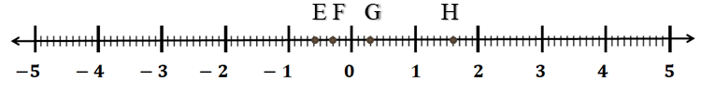

3.) On the number line below, which letter represents the graph of $\frac{43}{10}$?

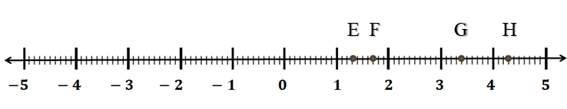

4.) On the number line below, which letter represents the graph of $-\frac{5}{2}$?

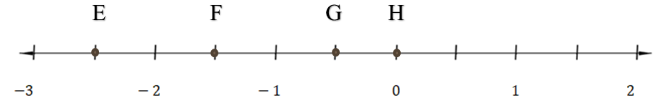

5.) On the number line below, which letter represents the graph of 3.2?

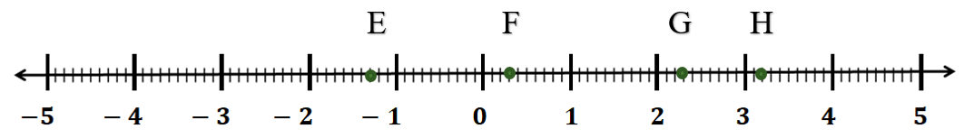

6.) On the number line below, which letter represents the graph of $-2\frac{7}{10}$?

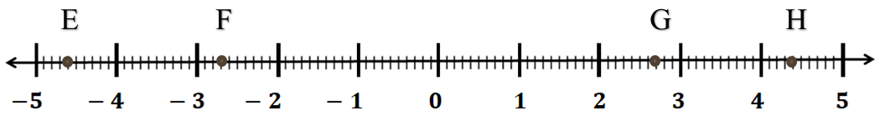

7.) On the number line below, which letter represents the graph of –16?

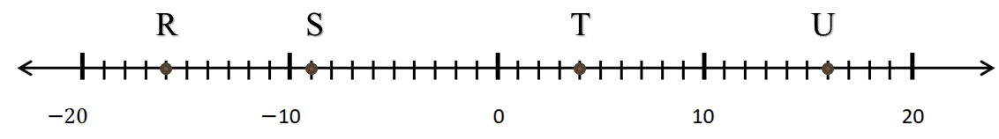

8.) On the number line below, which letter represents the graph of 13?

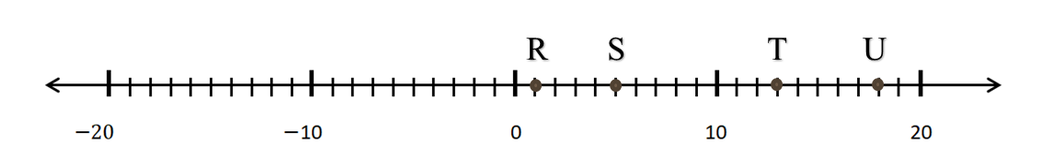

9.) On the number line below, which letter represents the graph of –1?

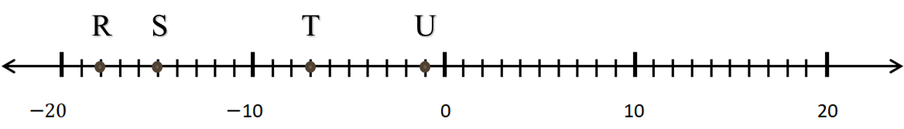

10.) On the number line below, which letter represents the graph of $1\frac{1}{2}$?

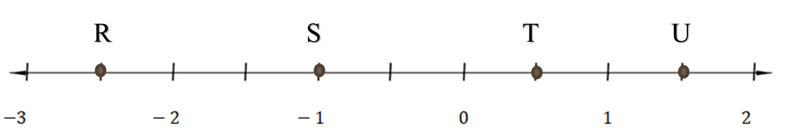

11.) On the number line below, which letter represents the graph of $-1\frac{1}{3}$?

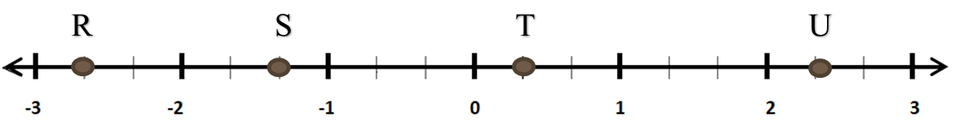

12.) On the number line below, which letter represents the graph of $\frac{8}{3}$?

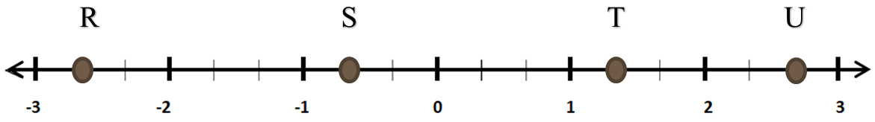

13.) On the number line below, which letter represents the graph of $-8\frac{2}{5}$?

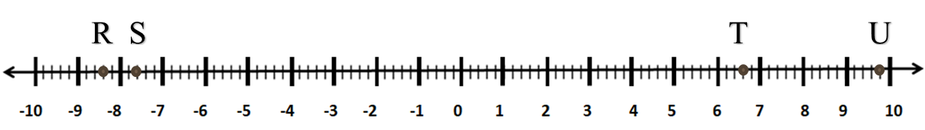

­­

# Part 3: Find the Absolute Value and Opposite of Rational Numbers.

**Identify the diagram that represents the correct way to find the absolute value of the given number.**

14.) Which diagram represents the correct way to find the absolute value of –5?

Number line A: 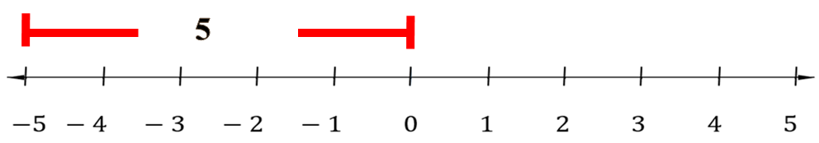

Number line B: 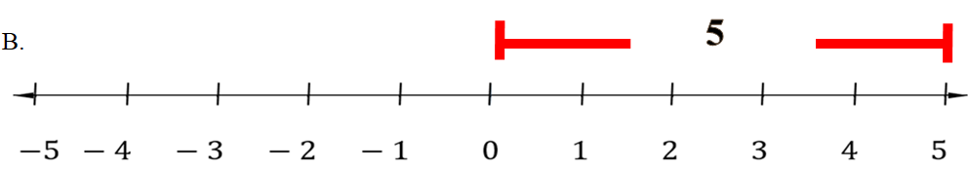

15.) Which diagram represents the correct way to find the absolute value of $-3\frac{1}{3}$?

Number line A:

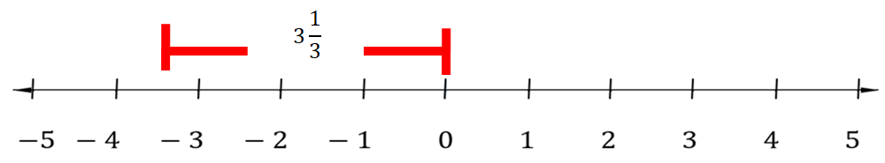

Number line B: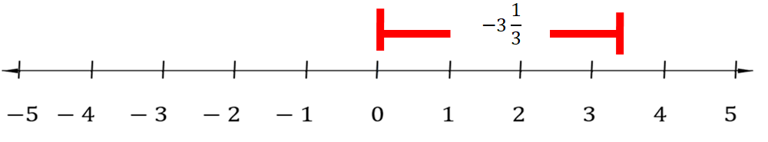

16.) Which diagram represents the correct way to find the absolute value of 10?

Number line A:

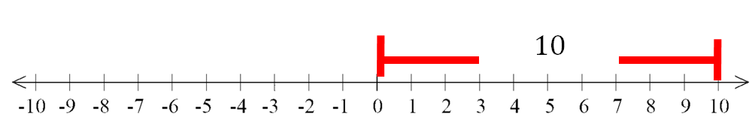

Number line B: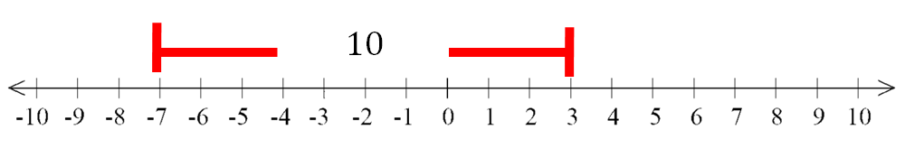

# Part 4: Find the Opposite

**Find the opposite of the given number.**

17.) What is the opposite of 8.5?

18.) What is the opposite of –­6?