**Name:**

**Date:**

**School:**

**Facilitator:**

1.06 Types of Matter

# Part 1: Complete the Chart

**Complete the graphic organizer showing the relationships between types of matter.**

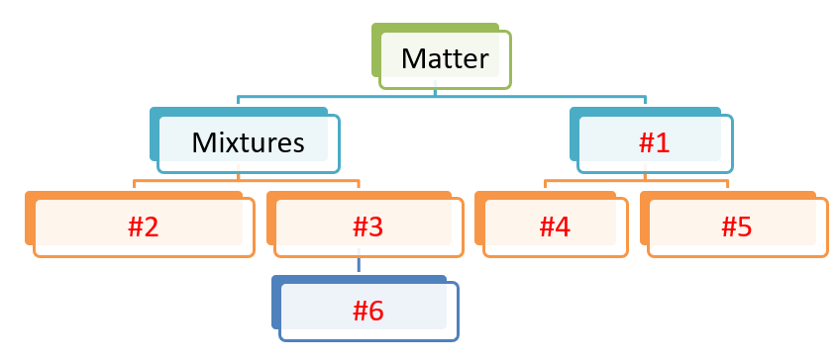

**Add your answers in the table below to complete the graphic organizer (shown above).**

|  |  |  |  |
| --- | --- | --- | --- |
| **Matter** | | | |
| **Mixtures** | | **#1:** | |
| **#2:** | **#3:** | **#4:** | **#5:** |
|  | **#6:** |  |  |

# Part 2: Review Questions

**Answer the following 4 questions.**

1. Name the two types of pure substances.
2. Aluminum and neon are      , and H2O & NaCl are      .
3. Molecules are made of at least       atoms.
4. Explain the difference between a homogeneous mixture and heterogeneous mixture. Name two example of each mixture [list different examples than were included in the lesson].
   1. Explanation:
   2. Homogeneous examples:
   3. Heterogeneous examples: